**Mathematics prosit-1**

**Game theory and strategic decision support**

Understanding Energy Management

1. *Learn how to assess a large city's energy needs for special events.*
2. *Understand the implications of using different energy sources, including renewables and industrial generators.*

Application of Game Theory

1. *Use game theory to model decision-making situations involving players with divergent interests.*
2. *Analyze possible scenarios and calculate Nash equilibria to determine optimal strategies.*

Risk Analysis and Decision Making

1. *Estimate and integrate probabilities of future events (such as weather) into decision-making.*
2. *Weigh the costs and benefits associated with different options to make an informed decision.*

Use of Data

1. *Use real data, such as weather forecasts, to inform decision-making.*
2. *Integrate open data into quantitative analyses to support practical conclusions.*

**Topic**

[**Energy challenge for the Paris Olympics**](https://moodle.cesi.fr/pluginfile.php/143023/mod_resource/content/1/co/_1_-_Mini_prosit_Theorie_des_jeux.html)

With just one week to go before the opening ceremony of the Olympic Games, Paris is faced with an exceptional demand for energy. Dense cloud cover threatens to cut solar production in half, threatening the stability of the energy grid. Marc, in charge of the city's energy network, needs to find an additional source of energy while minimizing costs in order to avoid a costly blackout estimated at 150 K€. To cope with this situation, Marc proposes renting an industrial generator from Diesel Pro for 50 K€, whereas the usual price is 70 K€. He includes a clause stipulating that the generator will only be used if solar production is insufficient, on condition that Diesel Pro agrees to rent it at 50 K€. If Diesel Pro refuses this offer and maintains the price at 70 K€, Marc indicates that he will use the generator even if solar production is sufficient. The use of the generator costs Diesel Pro 55 K€. However, if the generator is not used, the company will earn 50 K€ net if it accepts Marc's offer. Nicole, Diesel Pro's sales manager, has to decide whether to accept Marc's offer of 50 K€ or insist on the usual price of 70 K€. To resolve this dilemma, Marc and Nicole decide to put their proposals in writing on a sheet of paper and unveil them simultaneously. Marc will write down his proposed price (x) and Nicole will write down her proposed price (y). if x≥y, the rental price will be the minimum between x and y. If x<y, the generator will not be rented.

This situation prompts both players to think strategically about their decisions. They have to take into account the probability p of cloudy skies, the costs associated with a potential breakdown, and the profits or losses depending on agreement on the rental price. This is a classic game-theoretic problem, where each decision has direct and important economic consequences. By modelling this problem, it is possible to identify the expected gains for each player and each combination of strategies, and to determine an optimal strategic equilibrium where neither Marc nor Nicole would have any interest in deviating from their initial choice. Weather forecast taken from: meteorama.fr/

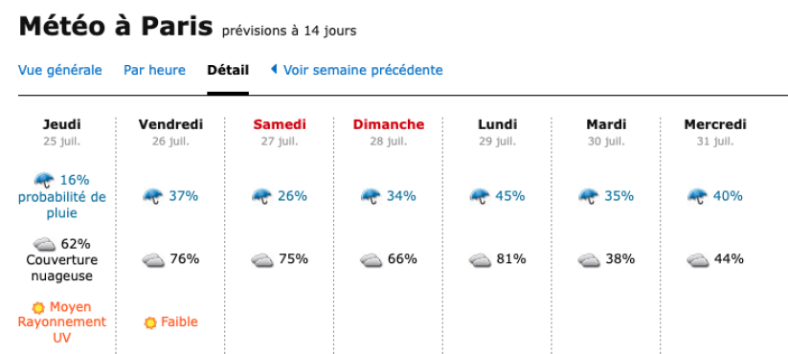

On a piece of scrap paper, Marc summarized the situation as follows:

|  |  |  |  |  |  |
| --- | --- | --- | --- | --- | --- |
|  |  | **Nicole** | | | |
|  |  | Accepter 50 k€ | | Insister sur 70 k€ | |
| **Marc** | ready to rent fo 50 k€ | Marc: avoids breakdown at lower cost if the sky is cloudy OR the sky is clear but pays 50 k€. | Nicole: Loses 5 k€ if the generator is used OR earns 50 k€ if it isn't | x<y, so the generator is not rented. Therefore, Marc risks a breakdown if the sky is overcast OR avoids the breakdown at no cost. | Nicole earns 0 in both cases |
| ready to rent 70 k€ | Marc: is ready to rent the genset for 70 k€ but Nicole accepts the discount: the genset is therefore rented for 50 k€. Marc avoids a breakdown at lower cost if the sky is cloudy OR if the sky is clear, but pays 50 k€. | Nicole: Loses 5 k€ if the generator is used OR earns 50 k€ if it isn't | The generator is rented for 70 k€, so Marc uses the generator in both cases. He therefore avoids a breakdown if the weather is cloudy OR pays 70 k€ for nothing if the weather is clear. | Nicole earns 5 k€ with a '**certain**' probability. |

**Resources for students**

* [Introduction à la théorie des jeux par l'exemple. [pdf]](https://moodle.cesi.fr/pluginfile.php/143023/mod_resource/content/1/res/Poly_Game_Theory.pdf)- EN
* Game Theory (pour aller plus loin): https://faculty.econ.ucdavis.edu/faculty/bonanno/PDF/GT_book.pdf

[**Instructions**](https://moodle.cesi.fr/pluginfile.php/143023/mod_resource/content/1/co/_1_-_Mini_prosit_Theorie_des_jeux.html)

**Quiz:Guided Workshop**

[Workshop Numéro 01 [pdf]](https://moodle.cesi.fr/pluginfile.php/143023/mod_resource/content/1/res/Sciences_Fondamentale_WS1-1.pdf)

[Notebook, code Python](https://moodle.cesi.fr/pluginfile.php/143023/mod_resource/content/1/co/_1_-_Mini_prosit_Theorie_des_jeux.html)